**Team M WORKS**

**Members:** MASAPA

**Overview:**

Many small business owners, especially sari-sari store owners, struggle to manage and track their inventory and restocking needs. They often rely on memory or handwritten logs, leading to issues such as running out of stock, over-ordering, or forgetting which products sell well. Without a proper system, these inefficiencies hurt profits and lead to missed sales opportunities.

That’s where **KITA KO Restocking App** comes in. It offers a simple, digital solution to help small business owners keep track of their inventory levels, monitor stock movement, and plan timely restocking. By improving the way they manage their store inventory, users can ensure that popular products are always available, minimize waste, and make smarter purchasing decisions.

**Solving the Problem:**

**KITA KO Restocking App** directly addresses the common issue of poor inventory management in small retail operations. With this app, users can track what’s in stock, what’s running low, and what needs to be reordered. This eliminates the guesswork and makes inventory handling more organized and reliable.

Even users with limited technical knowledge will find the app accessible. The app uses simple, easy-to-understand interfaces where users can add products, update stock levels, and set restocking alerts. Users can also see how fast products sell and make better decisions on what to restock and when.

By keeping records of stock movement and purchase history, KITA KO also helps small business owners identify which products generate the most income. This helps them optimize their shelf space and restocking budget. The app brings inventory control to the fingertips of sari-sari store owners and other small vendors, supporting better business growth and sustainability.

**The Application:**

* **Application Name:**  
   **KITA KO Restocking App** (Your Inventory and Stock Tracker)

**What it is:**

The **KITA KO Restocking App** is a smart inventory management tool designed for small business owners. Whether you run a sari-sari store or a mini shop, this app helps you track your inventory, set alerts when items are low, and record restocking history. With simple input options and clear summaries, users can stay on top of their product availability and never run out of their best-selling items again.

It empowers local business owners to plan purchases wisely, reduce excess stock, and monitor product performance with ease.

**Features:**

The team will have the following features incorporated into the application. Such features are as follows:

* **Add Product**  
   Users can add products with details such as name, quantity, and supplier.
* **Update Stock**  
   Allows users to increase or decrease item quantities based on sales or deliveries.
* **Set Restock Alerts**  
   Notifies users when a product reaches a low stock threshold.
* **View Inventory List**  
   Displays all current stock levels in a clear and organized way.
* **Restocking History**  
   Records when and how much of each item was restocked for tracking patterns.
* **Edit/Delete Items**  
   Users can update product details or remove items from their inventory.
* Additional features may be added depending on the feedback gathered from surveys with local business owners and users.

The team will also be adding more features depending on the results of the Survey handed to the participants.

**Questions About the Application**

**Q: What is the main purpose of the KITA KO Restocking App?**  
 **A:** To help small business owners track and manage their inventory for better restocking and sales management.

**Q: Who is the target user for this app?**  
 **A:** Sari-sari store owners, small vendors, and anyone managing retail inventory.

**Q: What basic features should the app have?**  
 **A:** Adding and updating products, viewing current stock, restocking alerts, and inventory reports.

**Q: Can users edit or delete product entries?**  
 **A:** Yes, product entries can be updated or removed at any time.

**Q: Is the app usable offline?**  
 **A:** Yes, it works offline and stores data locally for convenience.

**Q: Is the app secure?**  
 **A:** Yes, it includes basic protection like password login to keep inventory data private.

**Approach:**

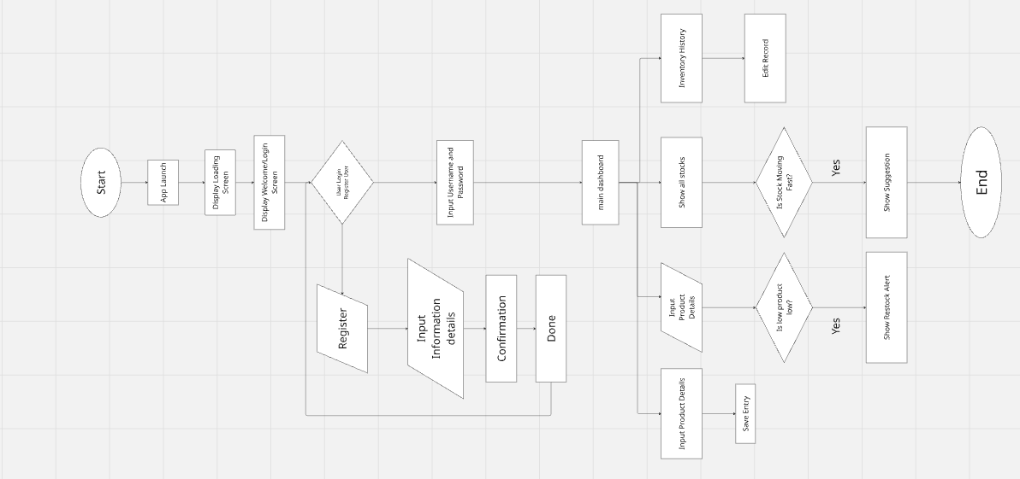

**Figure 1. Flowchart**